

NDIS workers and incident reporting

Aspect Research Centre for Autism Practice



Bold words
+  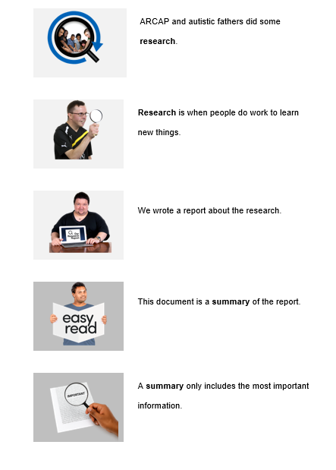 |  | Some words in this document are bold.
 |  | We write what the bold words mean.
Help with this document
You can get someone to help you
- understand this document
 |  | - find more information.
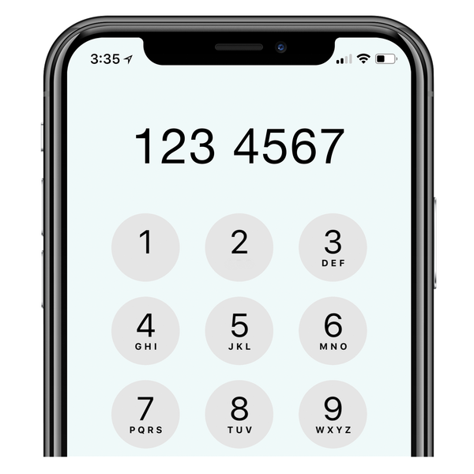  1800277328 |  | Contact information is at the end of this document.
About this document

 |  | This document is from the Aspect Research Centre for Autism Practice.
  ARCAP |  | We are called ARCAP for short.
 |  | When you see the word ‘we’ it means ARCAP.

About the research
 |  | ARCAP did some research.
 |  | Research is when people do work to learn new things.
 |  | We wrote a report about the research.
 |  | This document is a summary of the report.
 |  | A summary only includes the most important information.
Why we did the research
 |  | NDIS stands for the National Disability Insurance Scheme.
 |  | The NDIS helps people with disability get support.
 |  | The NDIS Quality and Safeguards Commission helps keep people safe.
 |  | NDIS workers help people with disability.
 |  | NDIS workers must tell the NDIS Quality and Safeguards Commission about incidents.
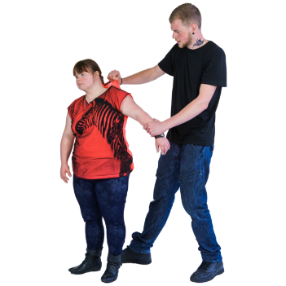 |  | An incident is something that harms a person with disability.
 |  | We wanted to find out about how NDIS workers report incidents.

How we did the research
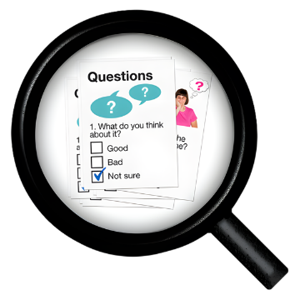 |  | We made a survey to find out about NDIS workers and incident reporting.
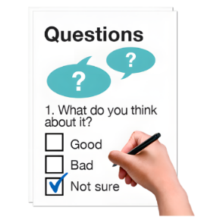 |  | A survey is a list of questions to find out what people think.
The survey was done by different NDIS workers
- behaviour support practitioners

 |  | - occupational therapists
 |  | - psychologists.

What the research is about

The survey asked NDIS workers

- what they know about reporting incidents

 |  | - who should report incidents
 |  | - what makes it hard to report incidents
 |  | - what helps to report incidents.

What did the research show?
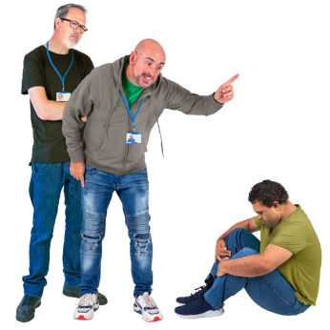 |  |  | Most NDIS workers said they could spot incidents.
 |  |  | They knew some things about reporting incidents but they did not know everything.
 |  |  | Many NDIS workers were not sure if they should report an incident.


Reporting incidents was hard because NDIS workers
- did not know how to do it

- did not know who to tell
- were worried that they would get in trouble.

It helped NDIS workers to report incidents when
- they knew how to do it
- they were supported by their manager
- they were trained
- it was easy to do.

Why this research is important
 |  | This research helps us find out what NDIS workers need to report incidents and keep people safe.

Contact us
 |  | If you want more information contact ARCAP.
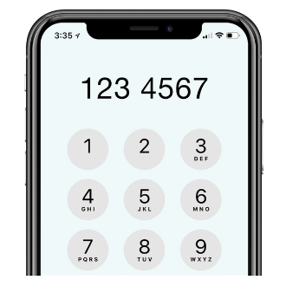  1800277328 |  | You can call 1800 277 328 and ask for ARCAP.
  aspect.org.au |  | You can go to our website aspect.org.au.
  customerengagement@aspect.org.au |  | You can email customerengagement@aspect.org.au.

